

**COMSATS UNIVERSITY ISLAMABAD, LAHORE CAMPUS**

**Title:**

**Lab Assignment**

**Subject:**

**Object Oriented Programing**

**Submitted to:**

**Sir Shahid Bhatti**

**Class:**

**SP24-BSE-A**

**Submitted by:**

**Nafeesa Mushtaq**

**Registration No:**

**SP24-BSE-096**

**Submission Date: November 29, 2024**

**Form:**

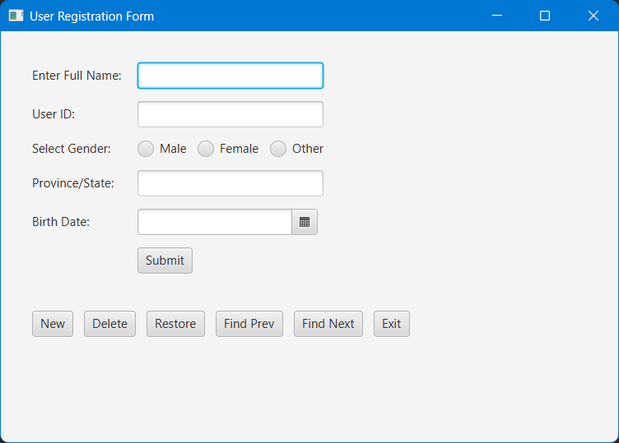

**Form Filling:**

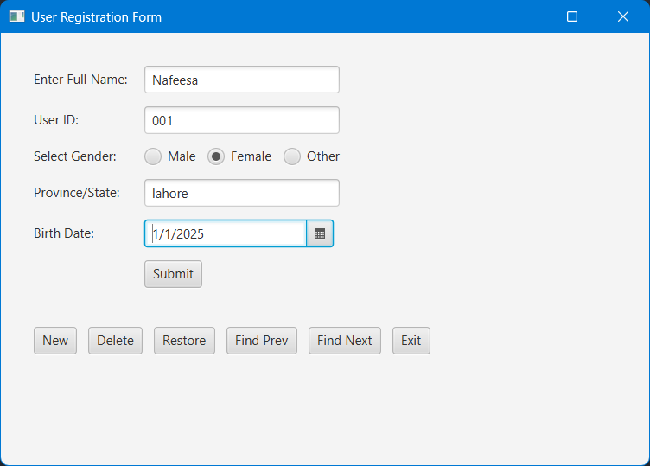

**Saved Data:**

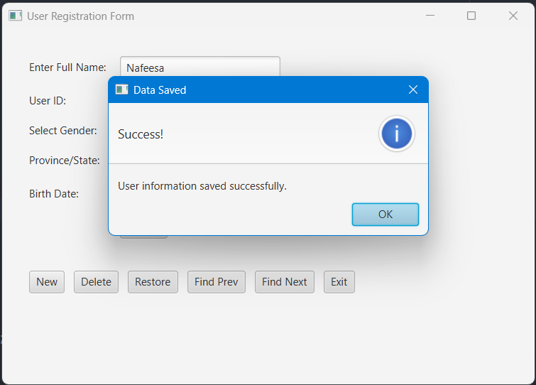

**File Handling:**

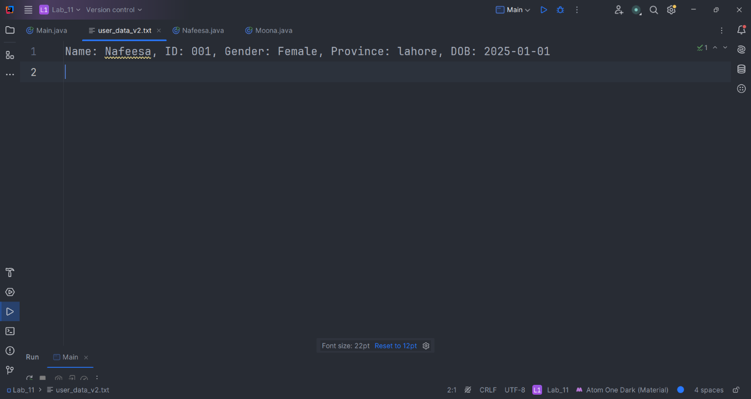

**Code:**

*import* javafx.application.Application;  
*import* javafx.geometry.Insets;  
*import* javafx.scene.Scene;  
*import* javafx.scene.control.*;  
*import* javafx.scene.layout.*;  
*import* javafx.stage.Stage;  
  
*import* java.io.BufferedWriter;  
*import* java.io.FileWriter;  
*import* java.io.IOException;  
  
*public class* Main *extends* Application {  
  
 @Override  
 *public void* start(Stage primaryStage) {  
 *// Main layout* VBox mainPane = *new* VBox(15);  
 mainPane.setPadding(*new* Insets(20));  
  
 *// Form section* GridPane formPane = *new* GridPane();  
 formPane.setPadding(*new* Insets(10));  
 formPane.setVgap(12);  
 formPane.setHgap(15);  
  
 *// Full Name* Label nameLabel = *new* Label("Enter Full Name:");  
 TextField nameField = *new* TextField();  
 formPane.add(nameLabel, 0, 0);  
 formPane.add(nameField, 1, 0);  
  
 *// ID* Label idLabel = *new* Label("User ID:");  
 TextField idField = *new* TextField();  
 formPane.add(idLabel, 0, 1);  
 formPane.add(idField, 1, 1);  
  
 *// Gender* Label genderLabel = *new* Label("Select Gender:");  
 RadioButton maleButton = *new* RadioButton("Male");  
 RadioButton femaleButton = *new* RadioButton("Female");  
 RadioButton otherButton = *new* RadioButton("Other");  
 ToggleGroup genderGroup = *new* ToggleGroup();  
 maleButton.setToggleGroup(genderGroup);  
 femaleButton.setToggleGroup(genderGroup);  
 otherButton.setToggleGroup(genderGroup);  
 HBox genderBox = *new* HBox(10, maleButton, femaleButton, otherButton);  
 formPane.add(genderLabel, 0, 2);  
 formPane.add(genderBox, 1, 2);  
  
 *// Province* Label provinceLabel = *new* Label("Province/State:");  
 TextField provinceField = *new* TextField();  
 formPane.add(provinceLabel, 0, 3);  
 formPane.add(provinceField, 1, 3);  
  
 *// Date of Birth* Label dobLabel = *new* Label("Birth Date:");  
 DatePicker dobPicker = *new* DatePicker();  
 formPane.add(dobLabel, 0, 4);  
 formPane.add(dobPicker, 1, 4);  
  
 *// Save button* Button saveButton = *new* Button("Submit");  
 formPane.add(saveButton, 1, 5);  
  
 *// Buttons Section (Below Form)* HBox buttonBox = *new* HBox(10);  
 Button newButton = *new* Button("New");  
 Button deleteButton = *new* Button("Delete");  
 Button restoreButton = *new* Button("Restore");  
 Button findPrevButton = *new* Button("Find Prev");  
 Button findNextButton = *new* Button("Find Next");  
 Button closeButton = *new* Button("Exit");  
 buttonBox.getChildren().addAll(newButton, deleteButton, restoreButton, findPrevButton, findNextButton, closeButton);  
 buttonBox.setPadding(*new* Insets(10));  
  
 *// Adding form and button sections to main layout* mainPane.getChildren().addAll(formPane, buttonBox);  
  
 *// Save Button Action* saveButton.setOnAction(e -> saveData(nameField, idField, genderGroup, provinceField, dobPicker));  
  
 *// Close Button Action* closeButton.setOnAction(e -> primaryStage.close());  
  
 *// Scene and Stage setup* Scene scene = *new* Scene(mainPane, 600, 400);  
 primaryStage.setTitle("User Registration Form");  
 primaryStage.setScene(scene);  
 primaryStage.show();  
 }  
  
 *private void* saveData(TextField nameField, TextField idField, ToggleGroup genderGroup, TextField provinceField, DatePicker dobPicker) {  
 *try* (BufferedWriter writer = *new* BufferedWriter(*new* FileWriter("user_data_v2.txt", *true*))) {  
 String name = nameField.getText().trim();  
 String id = idField.getText().trim();  
 RadioButton selectedGender = (RadioButton) genderGroup.getSelectedToggle();  
 String gender = selectedGender != *null* ? selectedGender.getText() : "Not Specified";  
 String province = provinceField.getText().trim();  
 String dob = dobPicker.getValue() != *null* ? dobPicker.getValue().toString() : "Not Specified";  
  
 *// Write data in a formatted way* writer.write("Name: " + name + ", ID: " + id + ", Gender: " + gender + ", Province: " + province + ", DOB: " + dob);  
 writer.newLine();  
  
 *// Confirmation alert* Alert alert = *new* Alert(Alert.AlertType.INFORMATION);  
 alert.setTitle("Data Saved");  
 alert.setHeaderText("Success!");  
 alert.setContentText("User information saved successfully.");  
 alert.showAndWait();  
 } *catch* (IOException ex) {  
 *// Error alert* Alert alert = *new* Alert(Alert.AlertType.ERROR);  
 alert.setTitle("Error");  
 alert.setHeaderText("Save Failed");  
 alert.setContentText("Could not save user data: " + ex.getMessage());  
 alert.showAndWait();  
 }  
 }  
  
 *public static void* main(String[] args) {  
 *launch*(args);  
}  
}